Food Database Design and Analysis

Jean Batista
Juniata College
DS 570 Database Systems
Elainea Neville

Table of Contents
Table of Contents 1
1. General Description of Database Purpose 1
2. Creating the 1,000-Row Sample 1
3. Database Creation — SQL DDL 1
3.1 serving_unit 1
3.2 food_category 1
3.3 brand 1
3.4 product 1
3.5 product_nutrition 1
3.6 Views 1
4. E-R Diagram and Documentation 1
4.1 Hand-Drawn Chen Notation ER Diagram 1
4.2 Entity and Relationship Summary 1
4.3 Design Decisions 1
5. Analysis Setup 1
6. Report 1: Descriptive Statistics and Sodium Investigation 1
6.1 Mean vs. Median by Nutrient 1
6.2 Sodium Distribution 1
6.3 Ranked Sodium Products and Data Error Investigation 1
6.4 Impact of Removing Outliers 1
7. Report 2: Harmful Nutrients and Category Variation 1
7.1 Sugar: Top Categories by Median Content 1
7.2 Trans Fat: Regulatory Context and Findings 1
7.3 Category Calorie Variation 1
7.4 Sodium by Category: % Exceeding FDA Threshold 1
8. Report 3: Multivariate Analysis and Nutritional Quality 1
8.1 Nutrient Correlation Heatmap 1
8.2 Macronutrient Caloric Composition 1
8.3 High Protein and High Fiber Products 1
8.4 Products with Good Nutrition and Low Harmful Nutrients 1

1. General Description of Database Purpose
This project builds a relational database from the USDA FoodData Central branded food dataset, one of the most comprehensive public sources of nutritional label data in the United States. The full master dataset contains over 1,026,891 product records. A 175,000-row random sample was provided as the working CSV. From that, a further 1,000-product random sample was drawn to serve as the operational database for this project.

The database stores nutritional information per serving as reported on product labels, including macronutrients, micronutrients, and serving size metadata. It is organized around a central product table linked to brand, food category, and serving unit lookup tables, with a separate nutrition table in a strict 1-to-1 relationship with the product table.

All analysis in this project is performed in Python against the 1,000-row sample CSV. The database and SQL DDL serve as the structured schema definition and storage layer. The three analytical reports cover descriptive statistics and data quality, harmful nutrient profiling by category, and multivariate nutritional quality analysis.

Property | Value
Database system | SQLite 3
Source dataset | USDA FoodData Central
Full source file | usda_branded_sample_175k_1.csv (175,000 rows, 16 columns)
Operational sample | 1,000 products (random seed = 42)
Tables | 5: serving_unit, food_category, brand, product, product_nutrition
Primary keys | 5 (one per table)
Foreign keys | 4 (brand_id, category_id, unit_id, product_id as PK+FK)
Total data columns | 21 across all tables
Unique brands | 581
Unique categories | 144

2. Creating the 1,000-Row Sample
The starting point is the 175,000-row CSV sample from the USDA master dataset. Before building the database, a reproducible 1,000-row sample is drawn using Python. This smaller sample is what gets loaded into the database and used for all subsequent analysis. The random seed is fixed at 42 to ensure reproducibility.

import pandas as pd

# Load the full 175k source file
df_full = pd.read_csv('usda_branded_sample_175k_1.csv', low_memory=False)
print(f'Full dataset: {df_full.shape[0]:,} rows, {df_full.shape[1]} columns')

# Draw a reproducible 1,000-row random sample
SAMPLE_N = 1000
RANDOM_SEED = 42

df_sample = df_full.sample(n=SAMPLE_N, random_state=RANDOM_SEED).reset_index(drop=True)

# Save to CSV — this file is what the database is built from
df_sample.to_csv('usda_sample_1k.csv', index=False)
print(f'Sample saved: {df_sample.shape[0]} rows')
print(f'Columns: {df_sample.columns.tolist()}')

The 16 columns in the sample CSV map directly to the database schema. The table below shows each column, its source name, and where it lands in the database.

CSV Column | Type | Maps To
company_brand | String | brand.brand_name
product | String | product.product_name
branded_food_category | String | food_category.category_name
serving_size | Float | product.serving_size
serving_size_unit | String | serving_unit.unit_code (after normalization)
calories_per_serving | Float | product_nutrition.calories_kcal
protein_g_per_serving | Float | product_nutrition.protein_g
carbs_g_per_serving | Float | product_nutrition.carbs_g
fat_g_per_serving | Float | product_nutrition.fat_g
fiber_g_per_serving | Float | product_nutrition.fiber_g
sodium_mg_per_serving | Float | product_nutrition.sodium_mg
cholesterol_mg_per_serving | Float | product_nutrition.cholesterol_mg
satfat_g_per_serving | Float | product_nutrition.saturated_fat_g
transfat_g_per_serving | Float | product_nutrition.trans_fat_g
total_sugar_g_per_serving | Float | product_nutrition.total_sugar_g
added_sugar_g_per_serving | Float | product_nutrition.added_sugar_g

3. Database Creation — SQL DDL
The database schema is defined in SQLite 3 SQL. Five tables are created. The serving_unit, food_category, and brand tables are lookup tables that normalize repeating string values. The product table is the central fact table with three foreign keys to the lookup tables. The product_nutrition table holds all nutrient values and uses product_id as both its primary key and its foreign key to product, enforcing a strict 1-to-1 relationship.

The schema is normalized to Third Normal Form. Brand names, category names, and unit codes are stored once in lookup tables and referenced by integer ID, eliminating all transitive dependencies from the product table.

3.1 serving_unit
Stores the five canonical serving size unit codes. The raw CSV contained multiple codes for the same physical unit (g, GRM, and GM all mean grams). These are collapsed to canonical codes at load time.

-- ============================================================
-- TABLE: serving_unit
-- Lookup for serving measurement units.
-- Raw codes normalized: GRM/GM -> g, MLT -> ml
-- ============================================================
CREATE TABLE serving_unit (
unit_id INTEGER PRIMARY KEY AUTOINCREMENT,
-- Surrogate primary key, auto-assigned
unit_code TEXT NOT NULL UNIQUE,
-- Canonical code: g, ml, MG, IU, MC
unit_label TEXT NOT NULL,
-- Human-readable: Grams, Milliliters, etc.
CHECK (unit_code IN ('g', 'ml', 'MG', 'IU', 'MC'))
-- CHECK 1: Only 5 valid canonical codes allowed
);

3.2 food_category
Stores USDA food category name strings. Products without a category are assigned 'Uncategorized' at load time.

-- ============================================================
-- TABLE: food_category
-- Lookup for USDA branded food category name strings.
-- ============================================================
CREATE TABLE food_category (
category_id INTEGER PRIMARY KEY AUTOINCREMENT,
category_name TEXT NOT NULL UNIQUE,
CHECK (LENGTH(category_name) > 0)
-- CHECK 2: No empty category name strings
);

3.3 brand
Stores company and brand name strings. Products without a brand are assigned 'Unknown Brand' at load time.

-- ============================================================
-- TABLE: brand
-- Lookup for company and brand name strings.
-- ============================================================
CREATE TABLE brand (
brand_id INTEGER PRIMARY KEY AUTOINCREMENT,
brand_name TEXT NOT NULL UNIQUE,
CHECK (LENGTH(brand_name) > 0)
-- CHECK 3: No empty brand name strings
);

3.4 product
The central fact table. Each row is one branded food product. Three foreign keys link to the lookup tables above.

-- ============================================================
-- TABLE: product
-- Central entity. One row per branded food product.
-- Foreign keys: brand_id, category_id, unit_id
-- ============================================================
CREATE TABLE product (
product_id INTEGER PRIMARY KEY AUTOINCREMENT,
product_name TEXT NOT NULL,
-- Product name as it appears on label
brand_id INTEGER REFERENCES brand(brand_id),
-- FK -> brand. Nullable (some products lack a brand).
category_id INTEGER REFERENCES food_category(category_id),
-- FK -> food_category.
serving_size REAL,
-- Numeric serving size amount. Nullable.
unit_id INTEGER REFERENCES serving_unit(unit_id),
-- FK -> serving_unit. Nullable.
CHECK (serving_size IS NULL OR serving_size > 0)
-- CHECK 4: serving_size must be positive if present
);

3.5 product_nutrition
Holds all nutritional values per serving for each product. product_id serves as both the primary key and foreign key to the product table, which enforces the 1-to-1 constraint at the schema level. A separate auto-increment key would add no information. All nutrient columns are nullable: NULL means the value was not reported on the label; zero means it was measured and found absent.

-- ============================================================
-- TABLE: product_nutrition
-- Per-serving nutritional values. One row per product.
-- product_id is PK and FK: enforces strict 1-to-1 with product.
-- NULL = not reported on label
-- Zero = measured and found absent
-- ============================================================
CREATE TABLE product_nutrition (
product_id INTEGER PRIMARY KEY REFERENCES product(product_id),
calories_kcal REAL, -- Total calories (kcal)
protein_g REAL, -- Protein (g)
carbs_g REAL, -- Total carbohydrates (g)
fat_g REAL, -- Total fat (g)
fiber_g REAL, -- Dietary fiber (g)
sodium_mg REAL, -- Sodium (mg)
cholesterol_mg REAL, -- Cholesterol (mg)
saturated_fat_g REAL, -- Saturated fat (g)
trans_fat_g REAL, -- Trans fat (g)
total_sugar_g REAL, -- Total sugars (g)
added_sugar_g REAL, -- Added sugars (g). Higher missingness.
CHECK (calories_kcal IS NULL OR calories_kcal >= 0),
-- CHECK 5a: Calories cannot be negative
CHECK (sodium_mg IS NULL OR sodium_mg >= 0)
-- CHECK 5b: Sodium cannot be negative
);

3.6 Views
Three views are defined to support common query patterns across all reports.

-- View 1: Full product record with all human-readable labels
CREATE VIEW v_product_full AS
SELECT p.product_id, p.product_name,
b.brand_name, fc.category_name,
p.serving_size, su.unit_label AS serving_unit,
pn.calories_kcal, pn.protein_g, pn.carbs_g, pn.fat_g,
pn.fiber_g, pn.sodium_mg, pn.cholesterol_mg,
pn.saturated_fat_g, pn.trans_fat_g,
pn.total_sugar_g, pn.added_sugar_g
FROM product p
JOIN brand b ON p.brand_id = b.brand_id
JOIN food_category fc ON p.category_id = fc.category_id
LEFT JOIN serving_unit su ON p.unit_id = su.unit_id
JOIN product_nutrition pn ON pn.product_id = p.product_id;

-- View 2: Products at or above FDA high-sodium threshold (460 mg)
CREATE VIEW v_high_sodium AS
SELECT p.product_id, p.product_name,
b.brand_name, fc.category_name,
pn.sodium_mg, pn.calories_kcal
FROM product_nutrition pn
JOIN product p ON pn.product_id = p.product_id
JOIN brand b ON p.brand_id = b.brand_id
JOIN food_category fc ON p.category_id = fc.category_id
WHERE pn.sodium_mg >= 460
ORDER BY pn.sodium_mg DESC;

-- View 3: Category-level average nutrition (5+ products per category)
CREATE VIEW v_category_nutrition_summary AS
SELECT fc.category_name,
COUNT(*) AS product_count,
ROUND(AVG(pn.calories_kcal), 1) AS avg_calories,
ROUND(AVG(pn.sodium_mg), 1) AS avg_sodium,
ROUND(AVG(pn.total_sugar_g), 1) AS avg_sugar,
ROUND(AVG(pn.protein_g), 1) AS avg_protein,
ROUND(AVG(pn.fat_g), 1) AS avg_fat,
ROUND(AVG(pn.fiber_g), 1) AS avg_fiber
FROM product_nutrition pn
JOIN product p ON pn.product_id = p.product_id
JOIN food_category fc ON p.category_id = fc.category_id
GROUP BY fc.category_name
HAVING COUNT(*) >= 5
ORDER BY avg_calories DESC;

4. E-R Diagram and Documentation

4.1 Hand-Drawn Chen Notation ER Diagram
The diagram below was drawn using Peter Chen notation. Rectangles are entities. Diamonds are relationships. Ovals are attributes. Underlined attributes are primary keys. Cardinality labels (1 and m) appear on each relationship line. The diagram corresponds directly to the DDL in Section 3.

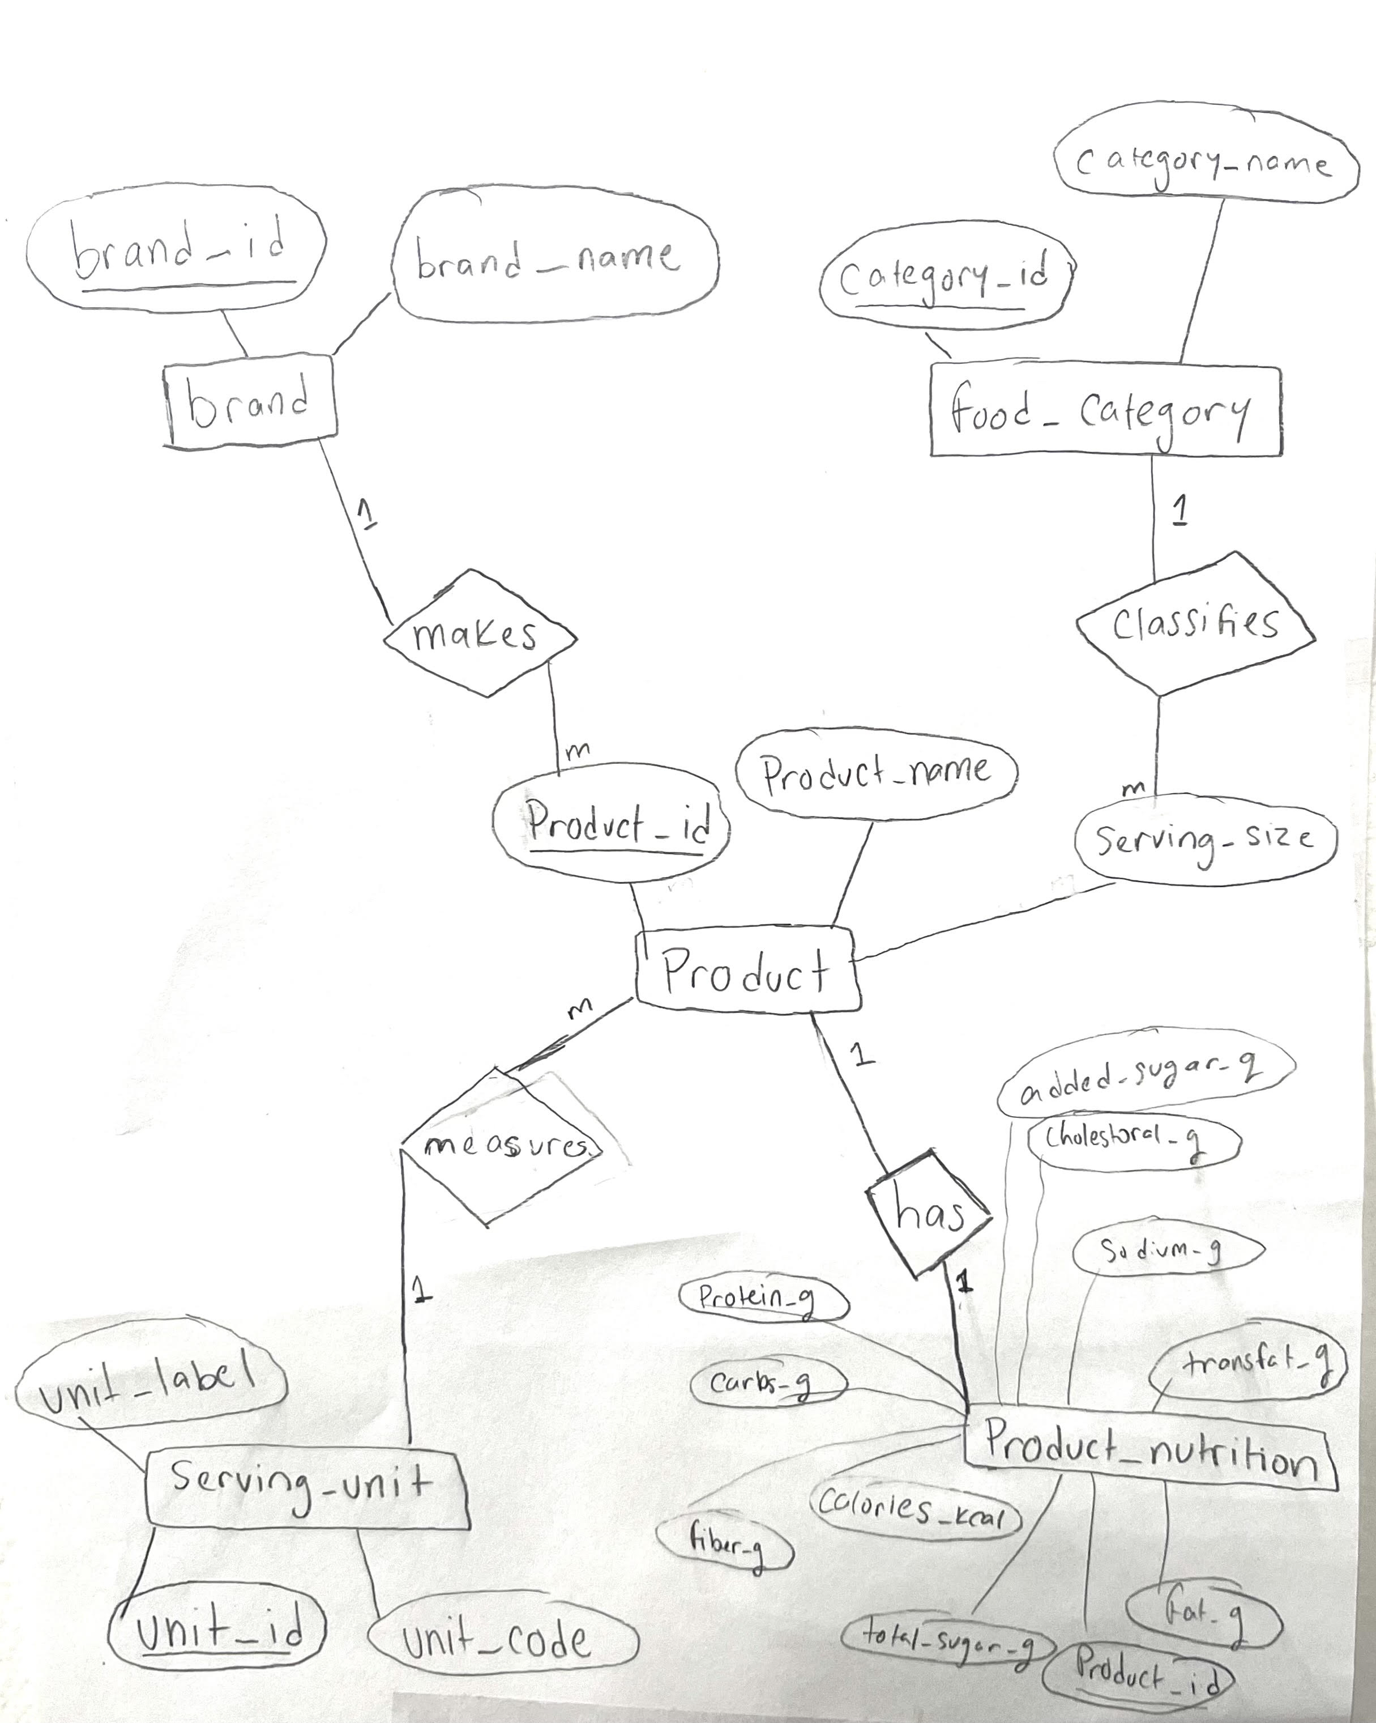
Figure 0. Hand-drawn Chen notation ER diagram for the USDA Branded Food database.

4.2 Entity and Relationship Summary
Entity | Role | Relationship | Cardinality
brand | Lookup: company and brand names | brand makes product | 1 brand to many products
food_category | Lookup: USDA food category strings | food_category classifies product | 1 category to many products
serving_unit | Lookup: canonical unit codes | serving_unit measures product | 1 unit to many products
product | Central fact table | product has product_nutrition | 1 product to 1 nutrition record
product_nutrition | Detail: all nutrient values | (see above) | Strict 1-to-1 with product

4.3 Design Decisions
1NF: Every table has an atomic, single-valued primary key. No repeating groups exist.
2NF: All non-key attributes depend fully on the primary key of their table. product_nutrition holds only facts about a specific product's nutritional label.
3NF: No transitive dependencies. Brand names and category names are stored in dedicated lookup tables and referenced by integer FK, not stored as strings in the product table.
product_nutrition uses product_id as its own PK rather than a separate surrogate because the relationship is strictly 1-to-1. A separate auto-increment ID would provide no additional information and no join path from other tables.
NULL in nutrient columns means the value was not reported on the product label. Zero means it was measured and found absent. These are distinct states and must not be conflated.

5. Analysis Setup
All analysis is performed in Python using the 1,000-row sample CSV. No SQL queries are required for the analysis; the CSV is loaded directly into a pandas DataFrame. The database schema defines the structure and serves as the reference for how data is organized. The Python code below is the common setup block used across all three reports.

import pandas as pd
import numpy as np
import matplotlib
matplotlib.use('Agg') # non-interactive backend
import matplotlib.pyplot as plt
import matplotlib.patches as mpatches

# Consistent plot style across all figures
plt.rcParams.update({
'font.family': 'DejaVu Sans', 'font.size': 10,
'axes.spines.top': False, 'axes.spines.right': False,
'axes.grid': True, 'grid.alpha': 0.3, 'grid.linestyle': '--',
'figure.facecolor': 'white', 'axes.facecolor': 'white'
})

# Load the 1,000-row sample
df = pd.read_csv('usda_sample_1k.csv', low_memory=False)

# Clean dataset: remove 16 products with sodium > 5,000 mg
# (physically impossible per-serving values — see Report 1 Section 3)
df_clean = df[
(df['sodium_mg_per_serving'].isna()) |
(df['sodium_mg_per_serving'] <= 5000)
].copy()

print(f'Full sample: {len(df)} products')
print(f'Clean sample: {len(df_clean)} products')

6. Report 1: Descriptive Statistics and Sodium Investigation
Report 1 examines the full 1,000-product sample to establish baseline descriptive statistics, then investigates sodium as the most anomalous nutrient. It identifies products with physically impossible sodium values, justifies a 5,000 mg per-serving cutoff for data cleaning, and quantifies the impact of removing those 16 products on overall statistics.

6.1 Mean vs. Median by Nutrient
When the mean sits well above the median, extreme values are pulling the average up. Sodium shows the largest divergence: mean 720 mg against a median of 298 mg, a 2.4x ratio. That gap confirms that a small number of extreme products are heavily skewing the mean. All other nutrients show much tighter mean/median alignment.

nutrients = [
'calories_per_serving', 'protein_g_per_serving', 'carbs_g_per_serving',
'fat_g_per_serving', 'sodium_mg_per_serving', 'total_sugar_g_per_serving',
'fiber_g_per_serving', 'satfat_g_per_serving'
]
labels = ['Calories\n(kcal)', 'Protein\n(g)', 'Carbs\n(g)', 'Fat\n(g)',
'Sodium\n(mg)', 'Total\nSugar (g)', 'Fiber\n(g)', 'Sat Fat\n(g)']

means = [df[n].mean() for n in nutrients]
medians = [df[n].median() for n in nutrients]

fig, ax = plt.subplots(figsize=(11, 5))
x = np.arange(len(nutrients))
w = 0.35
ax.bar(x - w/2, means, w, label='Mean', color='#2C6FAC', alpha=0.85, edgecolor='white')
ax.bar(x + w/2, medians, w, label='Median', color='#E05C2E', alpha=0.85, edgecolor='white')
ax.set_xticks(x)
ax.set_xticklabels(labels, fontsize=9)
ax.set_ylabel('Value (per serving)')
ax.set_title('Figure 1. Mean vs. Median by Nutrient', fontweight='bold')
ax.legend(fontsize=10)
plt.tight_layout()
plt.savefig('r1_fig1_mean_median.png', dpi=150, bbox_inches='tight')

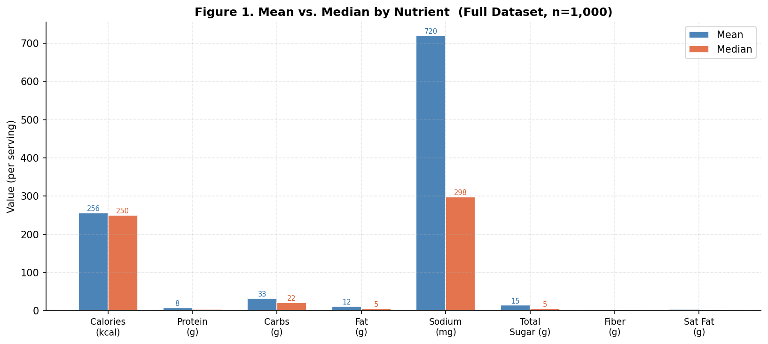
Figure 1. Mean vs. Median by Nutrient (full dataset, n=1,000). The sodium bar shows the largest mean/median gap by far.

Nutrient | Mean | Median | Std Dev | 25th Pct | 75th Pct
Calories (kcal) | 256.0 | 250.0 | 201.0 | 80.0 | 393.0
Protein (g) | 7.6 | 4.6 | 11.0 | 2.2 | 10.0
Carbohydrates (g) | 32.6 | 21.7 | 31.7 | 7.1 | 44.9
Fat (g) | 11.6 | 5.4 | 15.2 | 0.0 | 18.4
Sodium (mg) | 720.0 | 298.0 | 2,877.0 | 50.0 | 571.0
Total Sugar (g) | 14.8 | 5.1 | 20.6 | 1.2 | 22.5
Fiber (g) | 2.7 | 1.5 | 4.6 | 0.0 | 3.6
Saturated Fat (g) | 4.8 | 2.3 | 7.2 | 0.4 | 6.3
Trans Fat (g) | 0.0 | 0.0 | 0.4 | 0.0 | 0.0

6.2 Sodium Distribution
The FDA classifies any food with 460 mg or more of sodium per serving as high-sodium. In this sample, 33.4% of products with sodium data exceed that threshold. The histogram below shows most products cluster below 1,000 mg, but a long tail extends far to the right and beyond the chart boundary.

sod = df['sodium_mg_per_serving'].dropna()
sod_clip = sod[sod <= 3000]

fig, ax = plt.subplots(figsize=(10, 4.5))
ax.hist(sod_clip, bins=50, color='#2C6FAC', alpha=0.8, edgecolor='white')
ax.axvline(460, color='#E05C2E', lw=2, linestyle='--', label='FDA High Sodium: 460 mg')
ax.axvline(sod.median(), color='#333', lw=1.5, linestyle=':', label=f'Median: {sod.median():.0f} mg')
ax.axvline(sod.mean(), color='#888', lw=1.5, linestyle=':', label=f'Mean: {sod.mean():.0f} mg')
ax.set_xlabel('Sodium per Serving (mg)')
ax.set_ylabel('Number of Products')
ax.set_title('Figure 2. Sodium Distribution (clipped at 3,000 mg)', fontweight='bold')
ax.legend(fontsize=9)
pct = (sod >= 460).mean()
ax.text(0.97, 0.93, f'{pct:.1%} exceed 460 mg', transform=ax.transAxes, ha='right',
fontsize=9, color='#E05C2E',
bbox=dict(boxstyle='round,pad=0.3', facecolor='#FFF3EE', edgecolor='#E05C2E'))
plt.tight_layout()
plt.savefig('r1_fig2_sodium_dist.png', dpi=150, bbox_inches='tight')

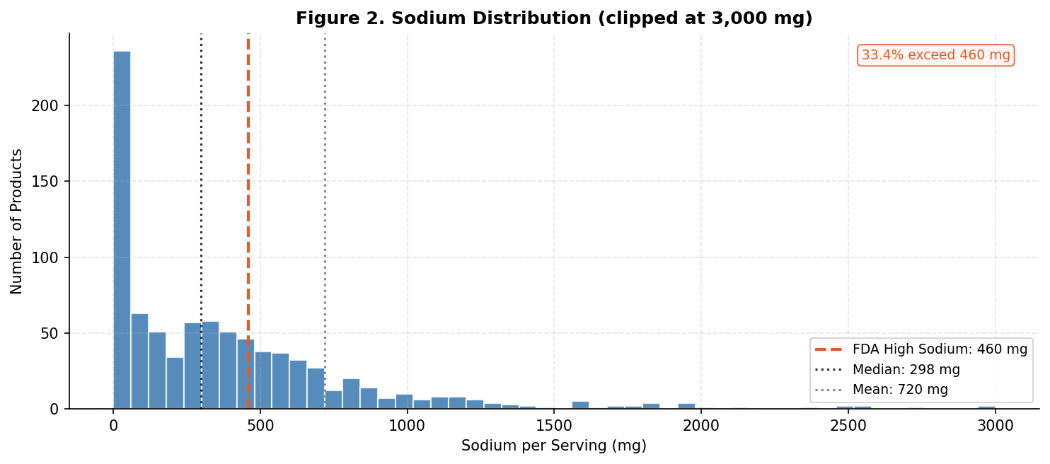
Figure 2. Sodium distribution clipped at 3,000 mg. The histogram excludes several extreme values above the plotted range.

6.3 Ranked Sodium Products and Data Error Investigation
The bar chart below ranks the top 20 highest-sodium products. All 16 products above 5,000 mg are colored dark red. These are dry spice blends and salts with sub-5g serving sizes. A 1.5g serving of table salt at most yields roughly 590 mg of sodium (salt is 39% sodium by mass). Values of 40,000 mg on a 1.5g serving exceed the total mass of salt that could even be present. These represent per-100g data entered as per-serving data, a known USDA data entry error pattern.

top_sod = df.nlargest(20, 'sodium_mg_per_serving')[
['product', 'company_brand', 'branded_food_category', 'sodium_mg_per_serving']
].copy()
top_sod['short'] = top_sod['product'].str[:42]
top_sod = top_sod.sort_values('sodium_mg_per_serving', ascending=True)

colors = ['#C0392B' if s > 5000
else '#E05C2E' if s > 2000
else '#2C6FAC'
for s in top_sod['sodium_mg_per_serving']]

fig, ax = plt.subplots(figsize=(11, 8))
ax.barh(range(len(top_sod)), top_sod['sodium_mg_per_serving'],
color=colors, edgecolor='white', alpha=0.9)
ax.set_yticks(range(len(top_sod)))
ax.set_yticklabels(top_sod['short'], fontsize=8)
ax.set_xlabel('Sodium (mg per serving)')
ax.set_title('Figure 3. Top 20 Highest-Sodium Products', fontweight='bold')
ax.axvline(5000, color='#C0392B', linestyle='--', lw=1.5, alpha=0.8)
ax.axvline(460, color='green', linestyle='--', lw=1.2, alpha=0.6)
# Add legend patches for color coding
red_p = mpatches.Patch(color='#C0392B', label='>5,000 mg (removed as data errors)')
orange_p = mpatches.Patch(color='#E05C2E', label='2,001-5,000 mg (retained)')
blue_p = mpatches.Patch(color='#2C6FAC', label='Up to 2,000 mg')
ax.legend(handles=[red_p, orange_p, blue_p], fontsize=8, loc='lower right')
for i, v in enumerate(top_sod['sodium_mg_per_serving']):
ax.text(v + 300, i, f'{v:,.0f} mg', va='center', fontsize=7.5)
plt.tight_layout()
plt.savefig('r1_fig3_sodium_ranked.png', dpi=150, bbox_inches='tight')

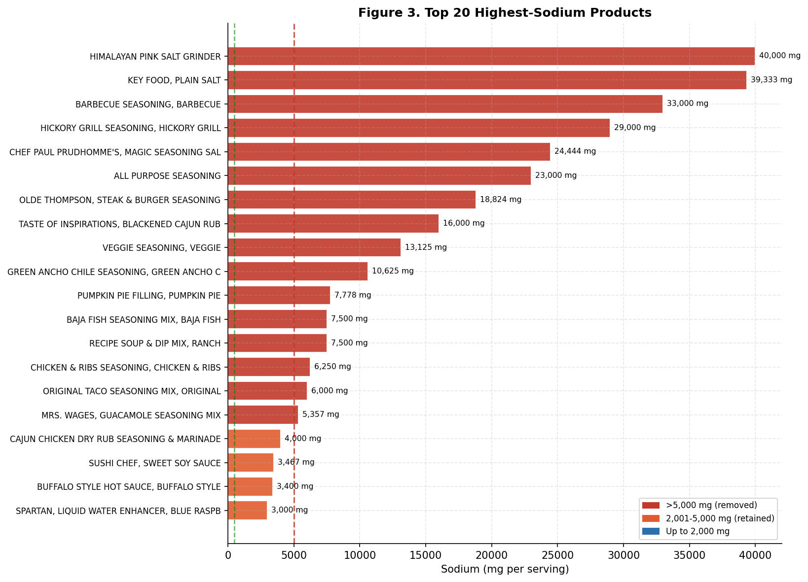
Figure 3. Top 20 highest-sodium products. Dark red bars exceed 5,000 mg and are removed from the cleaned dataset.

6.4 Impact of Removing Outliers
Applying the 5,000 mg cutoff removes 16 products, leaving 984 in the cleaned dataset used for Reports 2 and 3. The chart below shows the impact on means and medians. Sodium mean drops from 720 mg to 400 mg, a 44% reduction. The median shifts by only 12.5 mg, confirming its robustness to outliers. All other nutrient averages change by less than 3 units, confirming these were sodium-specific anomalies.

# Apply the sodium > 5000 filter
df_clean = df[
(df['sodium_mg_per_serving'].isna()) |
(df['sodium_mg_per_serving'] <= 5000)
].copy()

metrics = ['sodium_mg_per_serving', 'calories_per_serving',
'fat_g_per_serving', 'total_sugar_g_per_serving',
'protein_g_per_serving']
metric_labels = ['Sodium (mg)', 'Calories', 'Fat (g)', 'Sugar (g)', 'Protein (g)']

means_full = [df[m].mean() for m in metrics]
means_clean = [df_clean[m].mean() for m in metrics]
meds_full = [df[m].median() for m in metrics]
meds_clean = [df_clean[m].median() for m in metrics]

fig, axes = plt.subplots(1, 2, figsize=(11, 4.5))
x = np.arange(len(metrics))
w = 0.35

# Mean comparison
axes[0].bar(x-w/2, means_full, w, label=f'Full (n={len(df)})',
color='#C0392B', alpha=0.8, edgecolor='white')
axes[0].bar(x+w/2, means_clean, w, label=f'Cleaned (n={len(df_clean)})',
color='#2C6FAC', alpha=0.8, edgecolor='white')
axes[0].set_xticks(x)
axes[0].set_xticklabels(metric_labels, fontsize=8.5, rotation=15, ha='right')
axes[0].set_title('Mean: Before vs. After', fontsize=10, fontweight='bold')
axes[0].legend(fontsize=8)

# Median comparison
axes[1].bar(x-w/2, meds_full, w, label=f'Full (n={len(df)})',
color='#C0392B', alpha=0.8, edgecolor='white')
axes[1].bar(x+w/2, meds_clean, w, label=f'Cleaned (n={len(df_clean)})',
color='#2C6FAC', alpha=0.8, edgecolor='white')
axes[1].set_xticks(x)
axes[1].set_xticklabels(metric_labels, fontsize=8.5, rotation=15, ha='right')
axes[1].set_title('Median: Before vs. After', fontsize=10, fontweight='bold')
axes[1].legend(fontsize=8)

n_removed = len(df) - len(df_clean)
plt.suptitle(f'Figure 4. Impact of Removing {n_removed} Products with Sodium > 5,000 mg',
fontsize=11, fontweight='bold')
plt.tight_layout()
plt.savefig('r1_fig4_before_after.png', dpi=150, bbox_inches='tight')

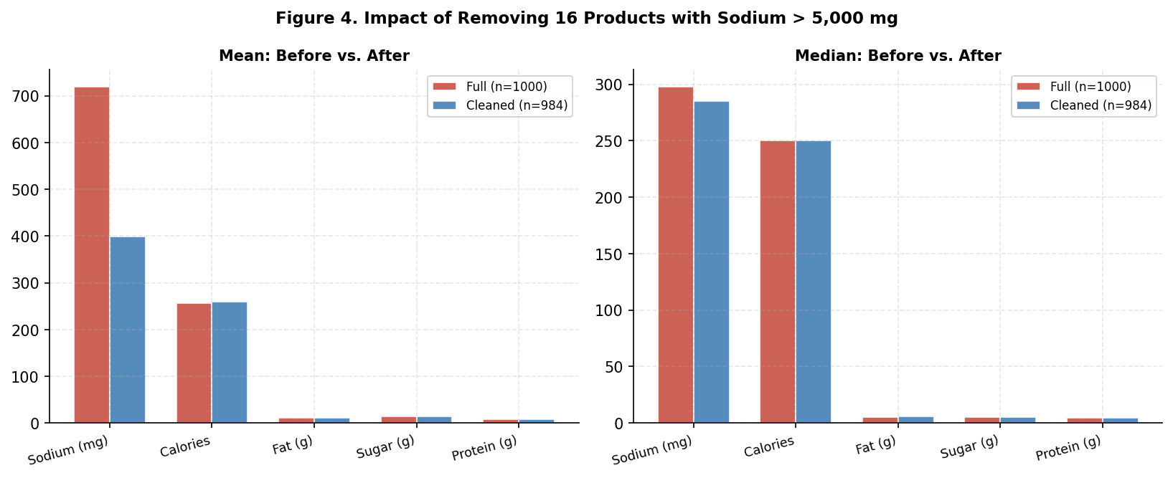
Figure 4. Mean and median statistics before and after removing 16 products with sodium > 5,000 mg.

Nutrient | Mean (Full) | Mean (Clean) | Median (Full) | Median (Clean) | Mean Change
Calories (kcal) | 256.0 | 259.1 | 250.0 | 250.0 | +3.1
Sodium (mg) | 720.0 | 399.5 | 298.0 | 285.5 | -320.5
Total Sugar (g) | 14.8 | 14.9 | 5.1 | 5.1 | +0.1
Fat (g) | 11.6 | 11.8 | 5.4 | 6.0 | +0.2
Protein (g) | 7.6 | 7.6 | 4.6 | 4.6 | 0.0
Carbohydrates (g) | 32.6 | 32.5 | 21.7 | 21.7 | -0.1

7. Report 2: Harmful Nutrients and Category Variation
Report 2 uses the cleaned 984-product dataset to profile harmful nutrients by food category. It covers sugar (total vs. added), trans fat in the context of FDA regulation, calorie variation across categories, and which food categories are most systematically high in sodium.

7.1 Sugar: Top Categories by Median Content
Jam, jelly, and fruit spreads lead with 60 g median total sugar. Candy follows at 56 g. The distinction between total sugar and added sugar reveals different nutritional profiles. Wholesome Snacks has 37.5 g total sugar but 0 g added sugar, all from natural sources like fruit and dates. Candy has 56.7 g added out of 56.2 g total, which is a labeling inconsistency (added cannot exceed total) and flags a data quality issue in that category.

cat_sugar = df_clean.groupby('branded_food_category').agg(
n=('product', 'count'),
med_total=('total_sugar_g_per_serving', 'median'),
med_added=('added_sugar_g_per_serving', 'median')
).reset_index()

top_sugar = (cat_sugar[cat_sugar['n'] >= 5]
.nlargest(12, 'med_total')
.sort_values('med_total', ascending=True))

fig, ax = plt.subplots(figsize=(11, 7.5))
y = np.arange(len(top_sugar))
# Total sugar (background bar)
ax.barh(y, top_sugar['med_total'], height=0.6,
color='#E05C2E', alpha=0.75, edgecolor='white', label='Median Total Sugar (g)')
# Added sugar overlay
ax.barh(y, top_sugar['med_added'].fillna(0), height=0.6,
color='#C0392B', alpha=0.9, edgecolor='white', label='Median Added Sugar (g)')
ax.set_yticks(y)
ax.set_yticklabels([c[:44] for c in top_sugar['branded_food_category']], fontsize=9)
ax.set_xlabel('Median Sugar per Serving (g)')
ax.set_title('Figure 5. Top 12 Categories by Median Total Sugar (n>=5 products)',
fontweight='bold')
ax.legend(fontsize=9, loc='lower right')
for i, ts in enumerate(top_sugar['med_total']):
ax.text(ts + 0.8, i, f'{ts:.1f}g', va='center', fontsize=8.5)
plt.tight_layout()
plt.savefig('r2_fig5_sugar.png', dpi=150, bbox_inches='tight')

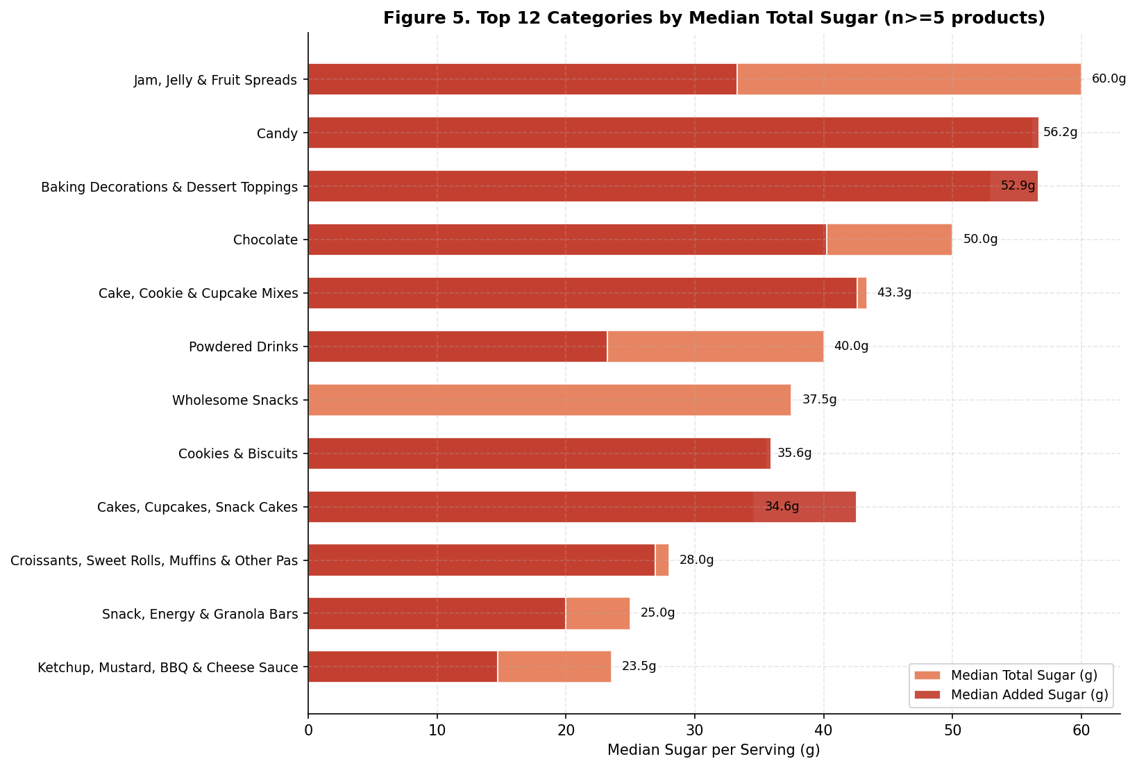
Figure 5. Top 12 food categories by median total sugar. Added sugar overlay shows how much is naturally occurring vs. added.

7.2 Trans Fat: Regulatory Context and Findings
The FDA determined in 2015 that partially hydrogenated oils (PHOs), the primary source of artificial trans fat, were no longer Generally Recognized as Safe. Manufacturers had until January 2020 to comply. The data reflects this: 95.7% of products with trans fat data report 0 g. The 4.3% reporting non-zero trans fat fall into two groups: animal products with naturally occurring trans fat (beef, pork, dairy), and legacy or trace-PHO products such as microwave popcorn and sweet bakery items.

tf_data = df_clean[df_clean['transfat_g_per_serving'].notna()]
zero_n = (tf_data['transfat_g_per_serving'] == 0).sum()
nonzero_n = (tf_data['transfat_g_per_serving'] > 0).sum()
total_n = len(tf_data)

# Category breakdown for non-zero products
tf_nonzero = df_clean[df_clean['transfat_g_per_serving'] > 0]
tf_by_cat = (tf_nonzero
.groupby('branded_food_category')
.agg(count=('product', 'count'),
avg_tf=('transfat_g_per_serving', 'mean'))
.reset_index()
.sort_values('count', ascending=True))

fig, axes = plt.subplots(1, 2, figsize=(12, 6))

# Pie chart
axes[0].pie(
[zero_n, nonzero_n],
labels=[f'Reports 0g\n{zero_n} products ({zero_n/total_n*100:.1f}%)',
f'Non-zero\n{nonzero_n} products ({nonzero_n/total_n*100:.1f}%)'],
colors=['#2C6FAC', '#C0392B'],
startangle=90,
wedgeprops={'edgecolor': 'white', 'linewidth': 2.5},
textprops={'fontsize': 10}
)
axes[0].set_title(f'Trans Fat: 0g vs. Non-Zero (n={total_n})',
fontsize=10, fontweight='bold')

# Category bar
colors_bar = ['#C0392B' if m > 1 else '#E05C2E' if m > 0.5 else '#F0A070'
for m in tf_by_cat['avg_tf']]
axes[1].barh(range(len(tf_by_cat)), tf_by_cat['count'],
color=colors_bar, edgecolor='white', alpha=0.9)
axes[1].set_yticks(range(len(tf_by_cat)))
axes[1].set_yticklabels(tf_by_cat['branded_food_category'].str[:38], fontsize=8)
axes[1].set_xlabel('Number of Products with Trans Fat > 0')
axes[1].set_title('Categories with Non-Zero Trans Fat', fontsize=10, fontweight='bold')
for i, (cnt, avg) in enumerate(zip(tf_by_cat['count'], tf_by_cat['avg_tf'])):
axes[1].text(cnt+0.05, i, f'{cnt} avg {avg:.2f}g', va='center', fontsize=8)

plt.suptitle('Figure 6. Trans Fat Analysis', fontsize=12, fontweight='bold')
plt.tight_layout()
plt.savefig('r2_fig6_transfat.png', dpi=150, bbox_inches='tight')

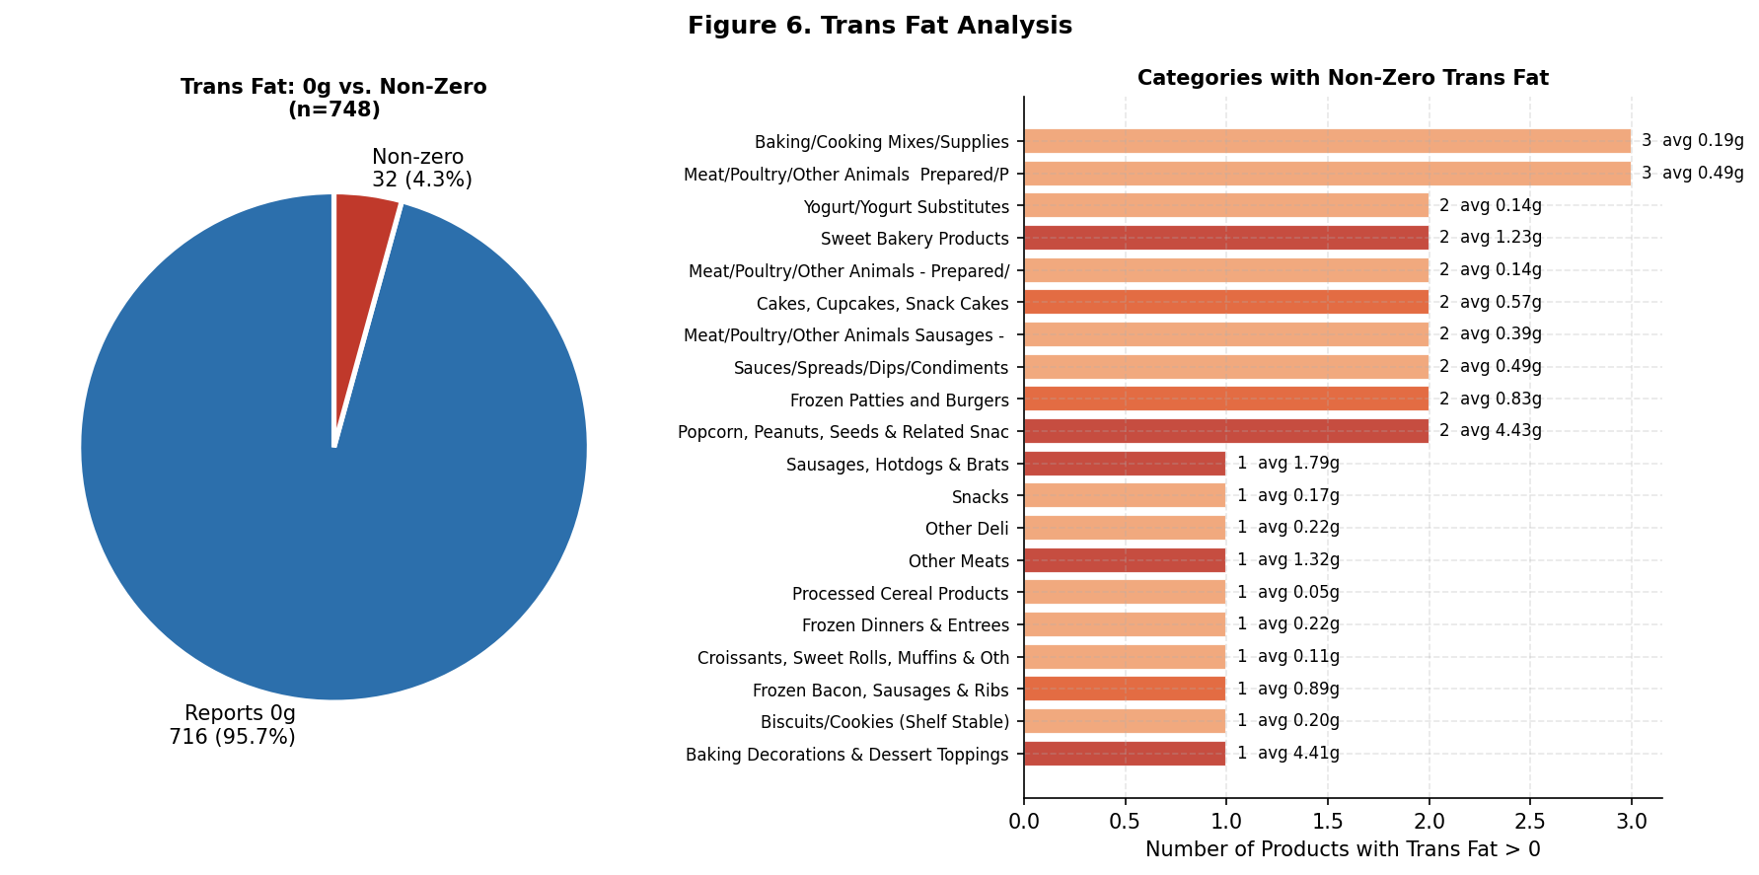
Figure 6. Trans fat breakdown. 95.7% of products report 0g. Non-zero reporters are color-coded by average grams per serving.

7.3 Category Calorie Variation
The sample contains 144 food categories. 63 of these have 5 or more products, which is the minimum for category-level comparisons. Cooking oils lead at 800 kcal median per serving, reflecting fat's caloric density at 9 kcal/g. Water sits at 0 kcal. The Other Drinks category shows a large mean/median gap (28 median vs. 238 mean), indicating high variance between diet drinks and protein shakes within the same category.

cat_cal = df_clean.groupby('branded_food_category').agg(
n=('product', 'count'),
med_cal=('calories_per_serving', 'median'),
avg_cal=('calories_per_serving', 'mean')
).reset_index()
cat5 = cat_cal[cat_cal['n'] >= 5]

high = cat5.nlargest(10, 'med_cal').sort_values('med_cal', ascending=True)
low = cat5.nsmallest(10, 'med_cal').sort_values('med_cal', ascending=False)

fig, axes = plt.subplots(1, 2, figsize=(14, 6.5))

axes[0].barh(range(len(high)), high['med_cal'],
color='#C0392B', alpha=0.85, edgecolor='white')
axes[0].set_yticks(range(len(high)))
axes[0].set_yticklabels([c[:40] for c in high['branded_food_category']], fontsize=8.5)
axes[0].set_xlabel('Median Calories per Serving (kcal)')
axes[0].set_title('10 Highest Calorie Categories', fontsize=11, fontweight='bold')
for i, (v, n) in enumerate(zip(high['med_cal'], high['n'])):
axes[0].text(v+5, i, f'{v:.0f} kcal (n={n})', va='center', fontsize=8)

axes[1].barh(range(len(low)), low['med_cal'],
color='#2C6FAC', alpha=0.85, edgecolor='white')
axes[1].set_yticks(range(len(low)))
axes[1].set_yticklabels([c[:40] for c in low['branded_food_category']], fontsize=8.5)
axes[1].set_xlabel('Median Calories per Serving (kcal)')
axes[1].set_title('10 Lowest Calorie Categories', fontsize=11, fontweight='bold')
for i, (v, n) in enumerate(zip(low['med_cal'], low['n'])):
axes[1].text(v+0.5, i, f'{v:.0f} kcal (n={n})', va='center', fontsize=8)

plt.suptitle('Figure 7. Category-Level Calorie Variation', fontsize=12, fontweight='bold')
plt.tight_layout()
plt.savefig('r2_fig7_cal_variation.png', dpi=150, bbox_inches='tight')

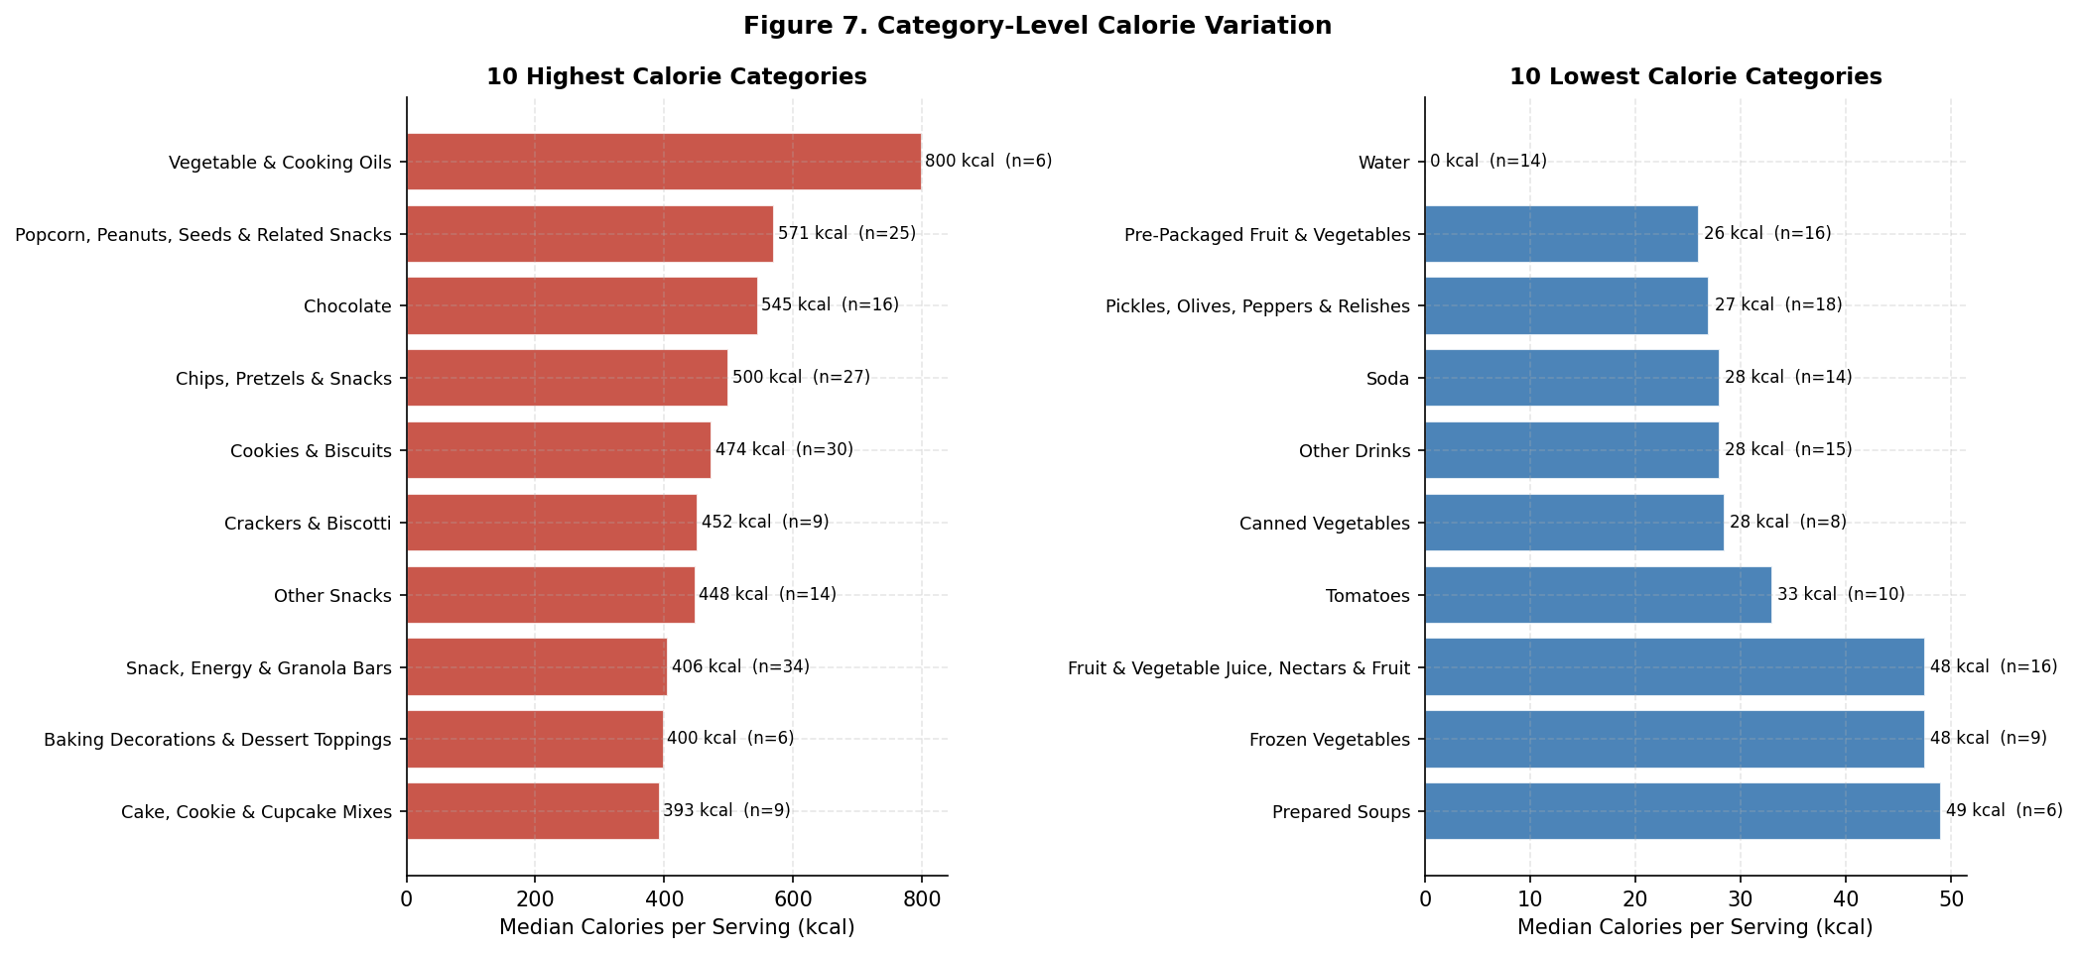
Figure 7. Highest and lowest calorie categories by median kcal per serving (categories with 5+ products).

7.4 Sodium by Category: % Exceeding FDA Threshold
This view shows which categories are systematically high in sodium, not just which have the highest average. Ketchup, mustard, BBQ, and cheese sauces lead: 94% of products exceed 460 mg. Condiments use salt as a primary flavor carrier and preservative. Pepperoni, salami, and cold cuts are second at 88%. Salt is essential to the curing and preservation process for these products. Cheese appears at 73%, driven by brining and emulsifying salts used in production.

cat_sod = df_clean.groupby('branded_food_category').agg(
n=('product', 'count'),
med_sodium=('sodium_mg_per_serving', 'median'),
pct_high=('sodium_mg_per_serving', lambda x: (x >= 460).mean() * 100)
).reset_index()

top_sod_pct = (cat_sod[cat_sod['n'] >= 5]
.nlargest(12, 'pct_high')
.sort_values('pct_high', ascending=True))

colors_sod = ['#C0392B' if p >= 80 else '#E05C2E' if p >= 60 else '#F0A070'
for p in top_sod_pct['pct_high']]

fig, ax = plt.subplots(figsize=(11, 7))
ax.barh(range(len(top_sod_pct)), top_sod_pct['pct_high'],
color=colors_sod, edgecolor='white', alpha=0.9)
ax.axvline(50, color='#333', linestyle='--', lw=1.2, alpha=0.5)
ax.set_yticks(range(len(top_sod_pct)))
ax.set_yticklabels([c[:42] for c in top_sod_pct['branded_food_category']], fontsize=9)
ax.set_xlabel('% of Products Exceeding 460 mg Sodium per Serving')
ax.set_title('Figure 8. Categories Where Most Products Exceed FDA High-Sodium Threshold',
fontweight='bold')
for i, (pct, med, n) in enumerate(zip(top_sod_pct['pct_high'],
top_sod_pct['med_sodium'],
top_sod_pct['n'])):
ax.text(pct+0.5, i, f'{pct:.0f}% (median {med:.0f} mg, n={n})',
va='center', fontsize=8.5)
ax.set_xlim(0, 120)
plt.tight_layout()
plt.savefig('r2_fig8_sodium_pct.png', dpi=150, bbox_inches='tight')

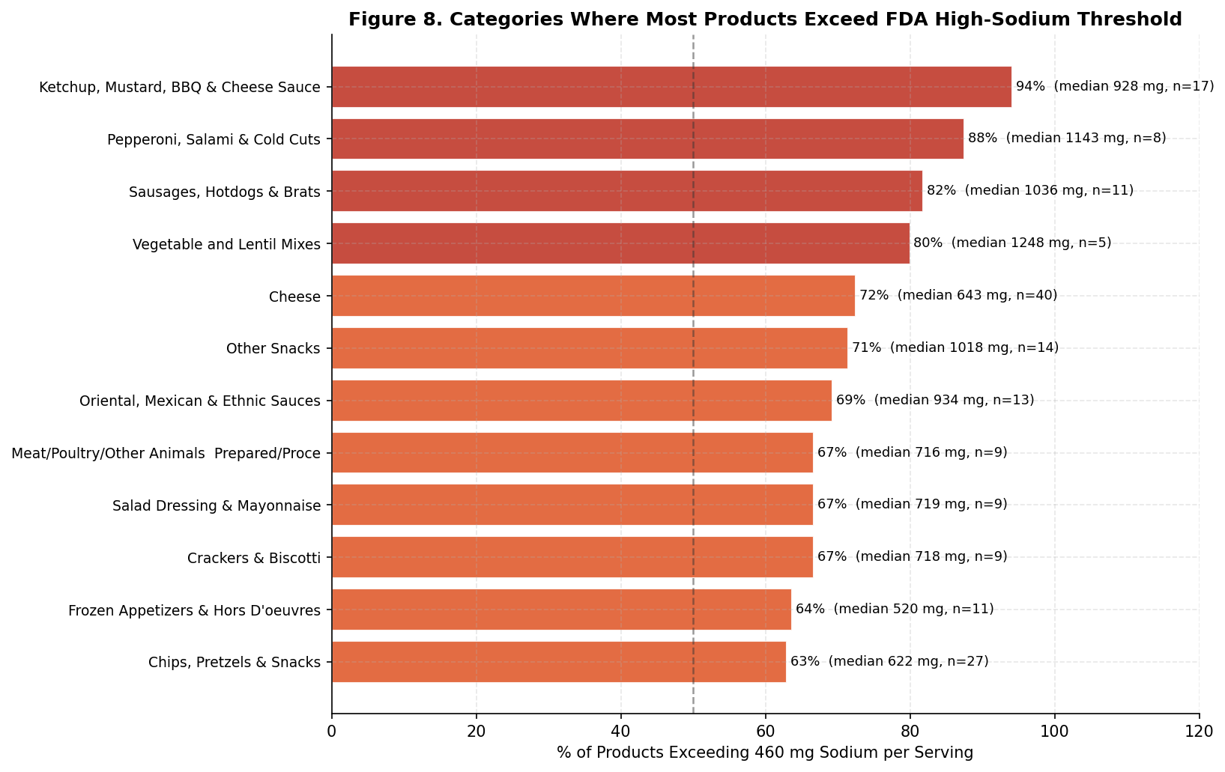
Figure 8. % of products exceeding the FDA 460 mg high-sodium threshold by category. Condiments and cured meats lead.

8. Report 3: Multivariate Analysis and Nutritional Quality
Report 3 examines relationships between nutrients via Pearson correlation, profiles macronutrient caloric composition, identifies 95 products with high protein and fiber and examines whether they also carry high harmful nutrients, and finally applies a 5-condition filter to find the 9 products that deliver good nutrition without the harmful nutrients.

8.1 Nutrient Correlation Heatmap
Fat and calories correlate at r=0.74, fat and saturated fat at r=0.73, and carbs and sugar at r=0.69. These reflect structural relationships: saturated fat is a subset of fat, fat is the most calorie-dense macronutrient, and sugar is a subset of carbohydrate. Sodium shows near-zero correlation with carbs, fat, and sugar, confirming it is driven by food type and processing rather than caloric density. Protein and fiber correlate at r=0.41, appearing together in legumes, whole grains, nuts, and seeds.

corr_cols = ['calories_per_serving', 'protein_g_per_serving',
'carbs_g_per_serving', 'fat_g_per_serving',
'fiber_g_per_serving', 'sodium_mg_per_serving',
'satfat_g_per_serving', 'transfat_g_per_serving',
'total_sugar_g_per_serving']
corr_labels = ['Calories', 'Protein', 'Carbs', 'Fat', 'Fiber',
'Sodium', 'Sat Fat', 'Trans Fat', 'Sugar']

corr = df_clean[corr_cols].corr()

fig, ax = plt.subplots(figsize=(9, 8))
im = ax.imshow(corr.values, cmap='RdBu_r', vmin=-1, vmax=1, aspect='auto')
ax.set_xticks(range(len(corr_labels)))
ax.set_xticklabels(corr_labels, rotation=45, ha='right', fontsize=9)
ax.set_yticks(range(len(corr_labels)))
ax.set_yticklabels(corr_labels, fontsize=9)
for i in range(len(corr_labels)):
for j in range(len(corr_labels)):
val = corr.values[i, j]
color = 'white' if abs(val) > 0.5 else 'black'
weight = 'bold' if abs(val) > 0.5 else 'normal'
ax.text(j, i, f'{val:.2f}', ha='center', va='center',
fontsize=8, color=color, fontweight=weight)
plt.colorbar(im, ax=ax, shrink=0.8, label='Pearson r')
ax.set_title('Figure 9. Nutrient Correlation Matrix (n=984)', fontsize=12, fontweight='bold')
plt.tight_layout()
plt.savefig('r3_fig9_corr.png', dpi=150, bbox_inches='tight')

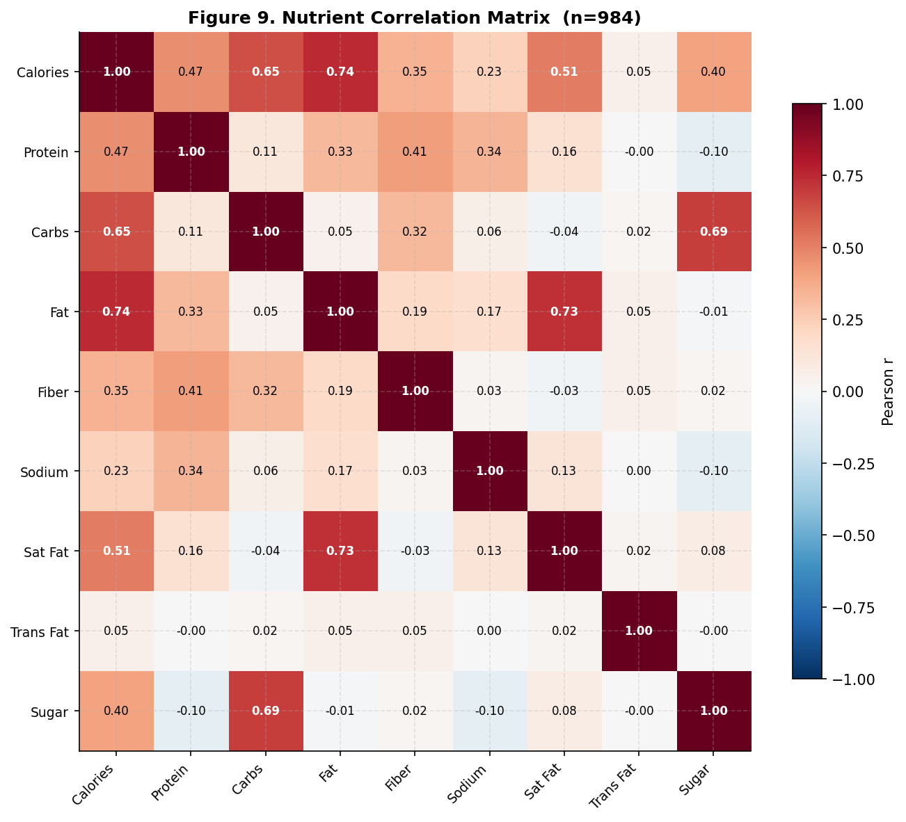
Figure 9. Pearson correlation matrix across all key nutrients (n=984, outliers removed). Bold values indicate r > 0.5.

8.2 Macronutrient Caloric Composition
Carbohydrates supply 54% of average calories, fat 32%, and protein 14%. The histogram reveals a bimodal carbohydrate distribution: a cluster near 0% (oils, cheeses, meats) and another near 80-100% (candy, soda, fruit products). The average of 54% sits between two very different groups of products. Protein median is 9.9%, well below its mean of 14.2%, because a small number of protein-concentrate products pull the average up. Most products in this sample are not meaningful protein sources.

macro = df_clean[df_clean['calories_per_serving'] > 0].dropna(
subset=['carbs_g_per_serving', 'fat_g_per_serving',
'protein_g_per_serving']).copy()

macro['carb_pct'] = (macro['carbs_g_per_serving'] * 4 / macro['calories_per_serving'] * 100).clip(0, 110)
macro['fat_pct'] = (macro['fat_g_per_serving'] * 9 / macro['calories_per_serving'] * 100).clip(0, 110)
macro['prot_pct'] = (macro['protein_g_per_serving'] * 4 / macro['calories_per_serving'] * 100).clip(0, 110)

mv = macro[(macro['carb_pct'] <= 110) & (macro['fat_pct'] <= 110) & (macro['prot_pct'] <= 110)]

avg_c = mv['carb_pct'].mean()
avg_f = mv['fat_pct'].mean()
avg_p = mv['prot_pct'].mean()

fig, axes = plt.subplots(1, 2, figsize=(13, 5.5))

# Histogram of caloric share distributions
axes[0].hist(mv['carb_pct'], bins=45, alpha=0.65, color='#2C6FAC', label=f'Carbs avg {avg_c:.1f}%')
axes[0].hist(mv['fat_pct'], bins=45, alpha=0.65, color='#C0392B', label=f'Fat avg {avg_f:.1f}%')
axes[0].hist(mv['prot_pct'], bins=45, alpha=0.65, color='#27AE60', label=f'Protein avg {avg_p:.1f}%')
axes[0].set_xlabel('Share of Calories from Macronutrient (%)')
axes[0].set_ylabel('Number of Products')
axes[0].set_title('Distribution of Caloric Share by Macronutrient', fontsize=10, fontweight='bold')
axes[0].legend(fontsize=9)
axes[0].set_xlim(0, 110)

# Pie chart of averages
labels_pie = [f'Carbs\n{avg_c:.1f}%', f'Fat\n{avg_f:.1f}%', f'Protein\n{avg_p:.1f}%']
axes[1].pie([avg_c, avg_f, avg_p], labels=labels_pie,
colors=['#2C6FAC', '#C0392B', '#27AE60'],
startangle=90,
wedgeprops={'edgecolor': 'white', 'linewidth': 2.5},
textprops={'fontsize': 11})
axes[1].set_title('Average Caloric Share', fontsize=10, fontweight='bold')

plt.suptitle(f'Figure 10. Macronutrient Caloric Composition (n={len(mv)})', fontsize=11, fontweight='bold')
plt.tight_layout()
plt.savefig('r3_fig10_macro.png', dpi=150, bbox_inches='tight')

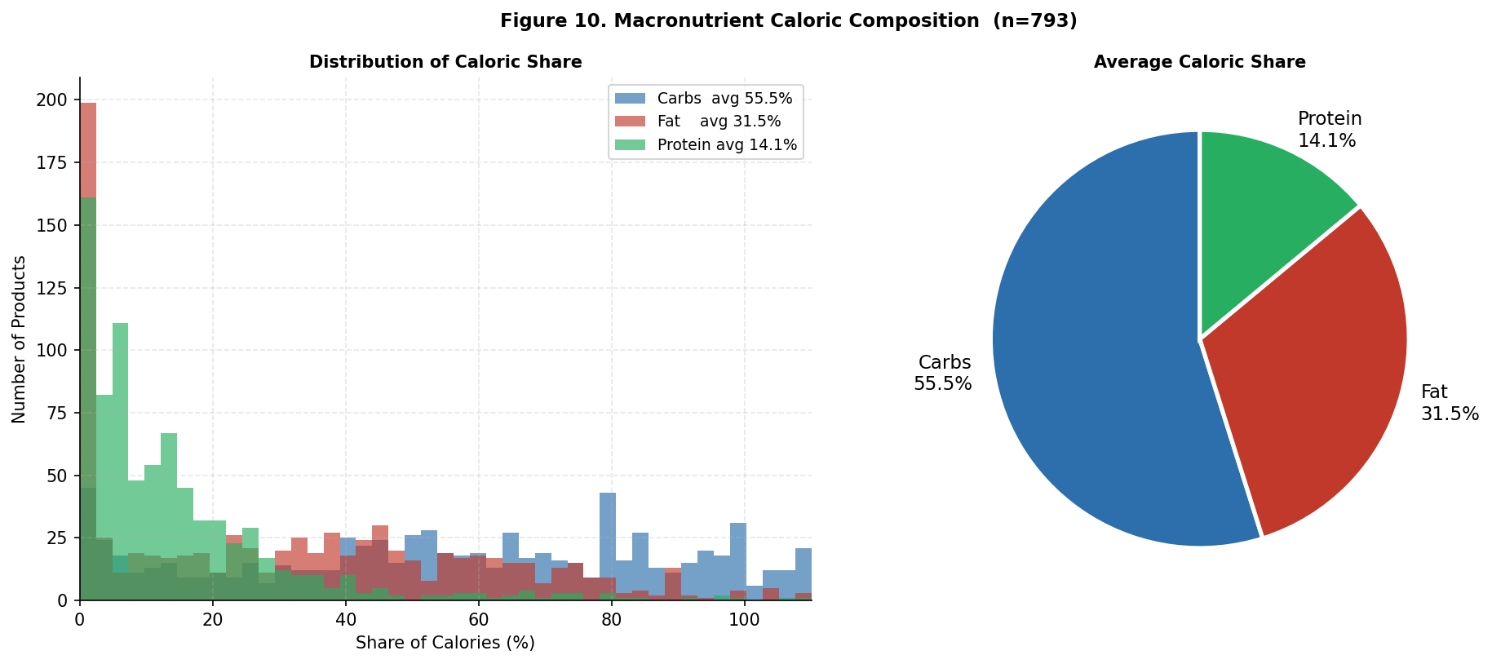
Figure 10. Macronutrient caloric composition. Left: distribution of each macro's share. Right: average breakdown.

8.3 High Protein and High Fiber Products
95 products meet both thresholds of 10g protein and 3g fiber per serving. The scatter plot highlights these against the full dataset. Color encodes protein content. The FDA 460 mg sodium line crosses the vertical axis. The key finding: 32.6% of high-protein, high-fiber products individually exceed 460 mg sodium. Their average fat (23 g) and calories (459 kcal) are both nearly double the full dataset averages. Nuts, seeds, and protein bars dominate this group and explain why.

good = df_clean[(df_clean['protein_g_per_serving'] >= 10) &
(df_clean['fiber_g_per_serving'] >= 3)].copy()
other = df_clean[~((df_clean['protein_g_per_serving'] >= 10) &
(df_clean['fiber_g_per_serving'] >= 3))].copy()

print(f'High protein + fiber: n={len(good)}')
print(f'Avg sodium: {good["sodium_mg_per_serving"].mean():.1f} mg')
print(f'Avg fat: {good["fat_g_per_serving"].mean():.1f} g')
print(f'Avg calories: {good["calories_per_serving"].mean():.1f} kcal')
print(f'% > 460mg Na: {(good["sodium_mg_per_serving"] >= 460).mean()*100:.1f}%')

fig, ax = plt.subplots(figsize=(9.5, 6.5))
ax.scatter(other['fat_g_per_serving'].clip(0, 80),
other['sodium_mg_per_serving'].clip(0, 2200),
c='#CCCCCC', alpha=0.2, s=14, edgecolors='none',
label=f'Other products (n={len(other)})')
sc = ax.scatter(good['fat_g_per_serving'].clip(0, 80),
good['sodium_mg_per_serving'].clip(0, 2200),
c=good['protein_g_per_serving'].clip(0, 55),
cmap='YlOrRd', alpha=0.85, s=55,
edgecolors='#333', linewidths=0.3,
label=f'High protein + fiber (n={len(good)})')
cbar = plt.colorbar(sc, ax=ax)
cbar.set_label('Protein (g per serving)', fontsize=9)
ax.axhline(460, color='#E05C2E', linestyle='--', lw=1.8,
alpha=0.85, label='FDA High Sodium (460 mg)')
ax.set_xlabel('Fat per Serving (g)')
ax.set_ylabel('Sodium per Serving (mg)')
ax.set_title(f'Figure 11. High Protein (>=10g) & Fiber (>=3g)\n'
f'Fat vs. Sodium (n={len(good)} highlighted)', fontweight='bold')
ax.legend(fontsize=9)
plt.tight_layout()
plt.savefig('r3_fig11_good_scatter.png', dpi=150, bbox_inches='tight')

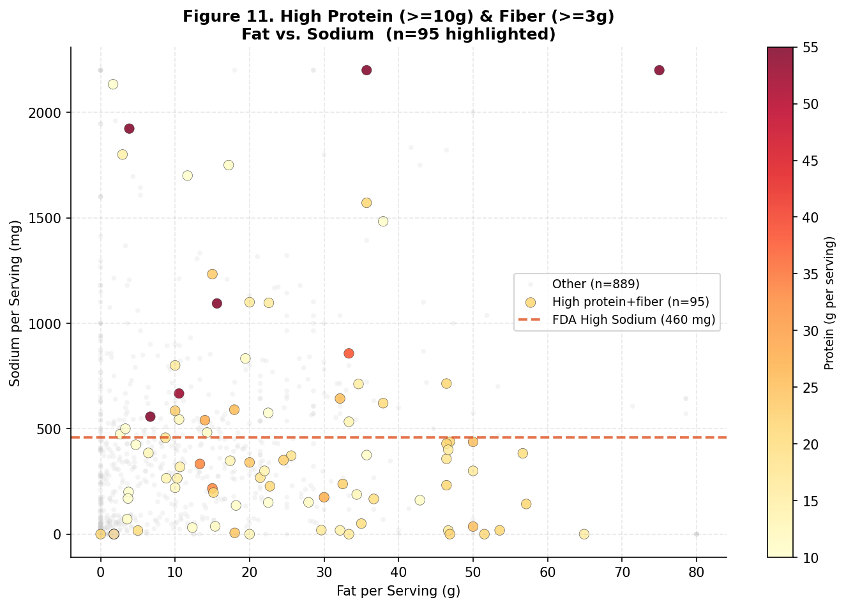
Figure 11. High protein + fiber products highlighted against the full dataset. Color = protein content. Dotted line = FDA sodium threshold.

8.4 Products with Good Nutrition and Low Harmful Nutrients
The 5-condition filter requires: protein >= 10g, fiber >= 3g, sodium <= 460 mg, saturated fat <= 3g, and total sugar <= 5g. Only 9 of 984 products pass all five conditions (0.9%). Five are dry pasta. The others are dried shiitake mushrooms, organic chia powder, a chickpea puff snack, and a Quest protein bar. The chart compares average nutrients across three groups: the full dataset, the high-protein group, and the best-profile group.

best = df_clean[
(df_clean['protein_g_per_serving'] >= 10) &
(df_clean['fiber_g_per_serving'] >= 3) &
(df_clean['sodium_mg_per_serving'] <= 460) &
(df_clean['satfat_g_per_serving'] <= 3) &
(df_clean['total_sugar_g_per_serving'] <= 5)
].copy()
print(f'Best profile products: {len(best)}')
print(best[['product', 'company_brand', 'branded_food_category',
'protein_g_per_serving', 'fiber_g_per_serving',
'sodium_mg_per_serving', 'satfat_g_per_serving',
'total_sugar_g_per_serving', 'calories_per_serving']])

metrics_b = ['protein_g_per_serving', 'fiber_g_per_serving',
'sodium_mg_per_serving', 'satfat_g_per_serving',
'total_sugar_g_per_serving', 'fat_g_per_serving',
'calories_per_serving']
labels_b = ['Protein (g)', 'Fiber (g)', 'Sodium (mg)',
'Sat Fat (g)', 'Sugar (g)', 'Fat (g)', 'Calories']

avgs_all = [df_clean[m].mean() for m in metrics_b]
avgs_good = [good[m].mean() for m in metrics_b]
avgs_best = [best[m].mean() for m in metrics_b]

x = np.arange(len(metrics_b))
w = 0.26
fig, ax = plt.subplots(figsize=(12, 5.5))
ax.bar(x-w, avgs_all, w, label=f'All products (n={len(df_clean)})',
color='#AAAAAA', alpha=0.85, edgecolor='white')
ax.bar(x, avgs_good, w, label=f'High protein+fiber (n={len(good)})',
color='#E05C2E', alpha=0.85, edgecolor='white')
ax.bar(x+w, avgs_best, w, label=f'Best profile (n={len(best)})',
color='#27AE60', alpha=0.9, edgecolor='white')
ax.set_xticks(x)
ax.set_xticklabels(labels_b, fontsize=9.5, rotation=12, ha='right')
ax.set_title('Figure 12. Avg Nutrient Profile: All vs. High Prot+Fib vs. Best Profile',
fontweight='bold')
ax.legend(fontsize=9)
for i, bv in enumerate(avgs_best):
ax.text(i+w, bv+max(avgs_all)*0.012, f'{bv:.0f}',
ha='center', va='bottom', fontsize=7.5,
color='#27AE60', fontweight='bold')
plt.tight_layout()
plt.savefig('r3_fig12_best_profile.png', dpi=150, bbox_inches='tight')

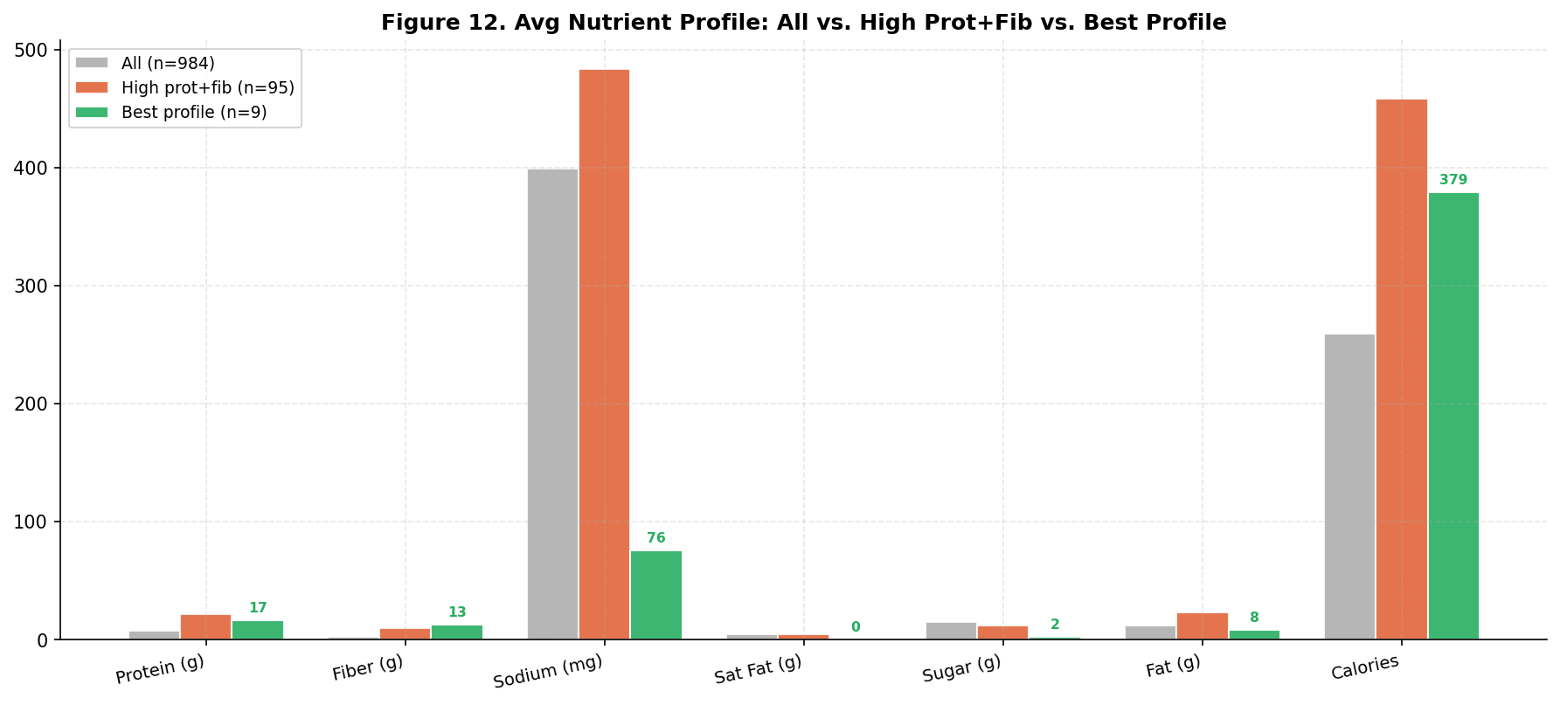
Figure 12. Average nutrient profile comparing all products, high protein+fiber group, and best-profile group.

Product | Brand | Category | Protein (g) | Fiber (g) | Sodium (mg) | Sat Fat (g) | Sugar (g) | Cal
ENRICHED MACARONI, FARFALLE... | Barilla | Pasta | 12.5 | 5.4 | 0 | 0.0 | 1.8 | 357
CHOCOLATE HAZELNUT PROTEIN BAR | Quest Nutrition | Protein Bars | 33.3 | 23.3 | 333 | 2.5 | 1.7 | 317
BAKED GREEN PEA & CHICKPEA PUFFS | Watusee Foods | Chips & Snacks | 13.0 | 13.0 | 348 | 0.0 | 4.4 | 435
NO. 66 BOW TIES PASTA | Riviana Foods | Pasta | 12.5 | 3.6 | 0 | 0.0 | 3.6 | 357
BRONZE CUT PAPPARDELLE | H E Butt Grocery | Pasta | 14.3 | 3.6 | 0 | 0.0 | 3.6 | 375
DRIED SHIITAKE MUSHROOMS | World Variety Produce | Baking/Extracts | 21.4 | 35.7 | 0 | 0.0 | 0.0 | 357
ENRICHED MACARONI, THIN SPAGHETTI | Target Stores | Pasta | 12.5 | 3.6 | 0 | 0.0 | 3.6 | 357
ORGANIC CHIA POWDER | Navitas, LLC | Wholesome Snacks | 16.7 | 25.0 | 0 | 0.0 | 0.0 | 500
JUMBO SHELLS | Meijer, Inc. | Pasta | 12.5 | 3.6 | 0 | 0.0 | 3.6 | 357

